**Problem Set 7 – Hello World in Assembly**

**Table of Contents**

|  |
| --- |
| 1. Source Code |
| * 1. Hello.S………………………………………….……………..pg. 1 |
| * 1. Exit.S………………………………………….………………pg. 1 |
| 1. Sample Run |
| * 1. Using Strace………………………….………………….……pg. 2 |
| * 1. Sample Run of Hello.S and Exit.S…………………………....pg. 3 |
| 1. Discussion |
| * 1. Exit Code………………………………….……….…………pg. 4 |
| * 1. System Call Validation....………………………….….………pg. 4 |
| 1. Extra Credit |
| * 1. Syscalltime.c…………………...……………………………...pg. 5 |
| * 1. Sample Run...…………………………………………………pg. 5 |
| * 1. Analysis………………………………………….……………pg. 6 |

1. **Source Code**
   1. **hello.S:**

.text

.global _start

_start:

movq $1, %rax #system call #1 (write)

movq $1, %rdi #output to stdout(1)

movq $msg, %rsi #message to output

movq $14, %rdx #length of msg rdx

syscall

.data

msg: .ascii "hello, world!\n"

* 1. **Code exit.S:**

.text

.global _start

_start:

movq $1, %rax #system call #1 (write)

movq $1, %rdi #output to stdout(1)

movq $msg, %rsi #message to output

movq $14, %rdx #length of msg rdx

syscall

movq $60, %rax

movq $1, %rdi #exit with 1 return

syscall

.data

msg: .ascii "hello, world!\n"

1. **Sample Run**
   1. **Using Strace**

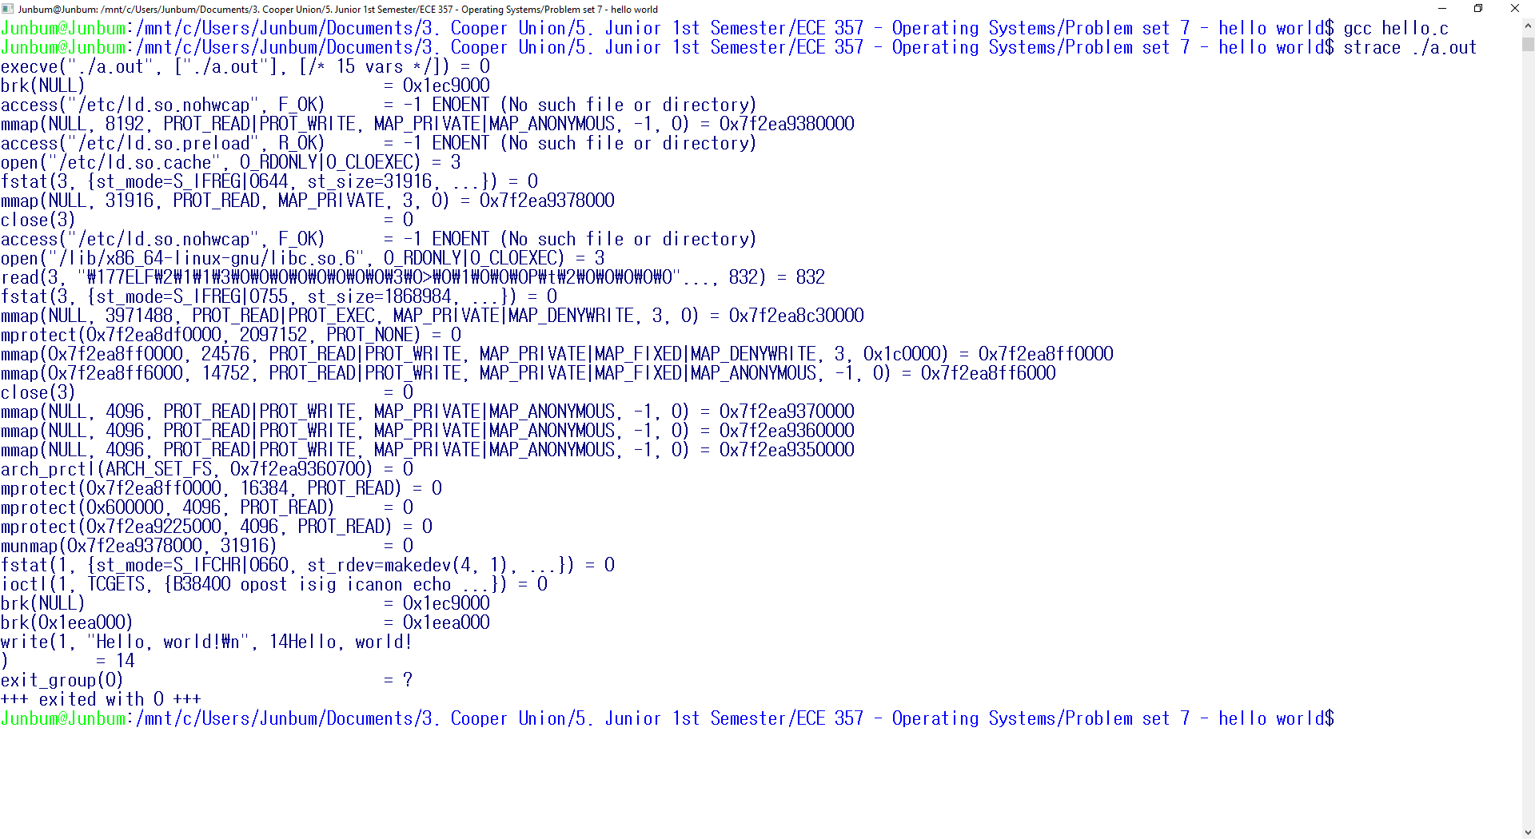

* 1. **Sample Run of Hello.S and Exit.S**

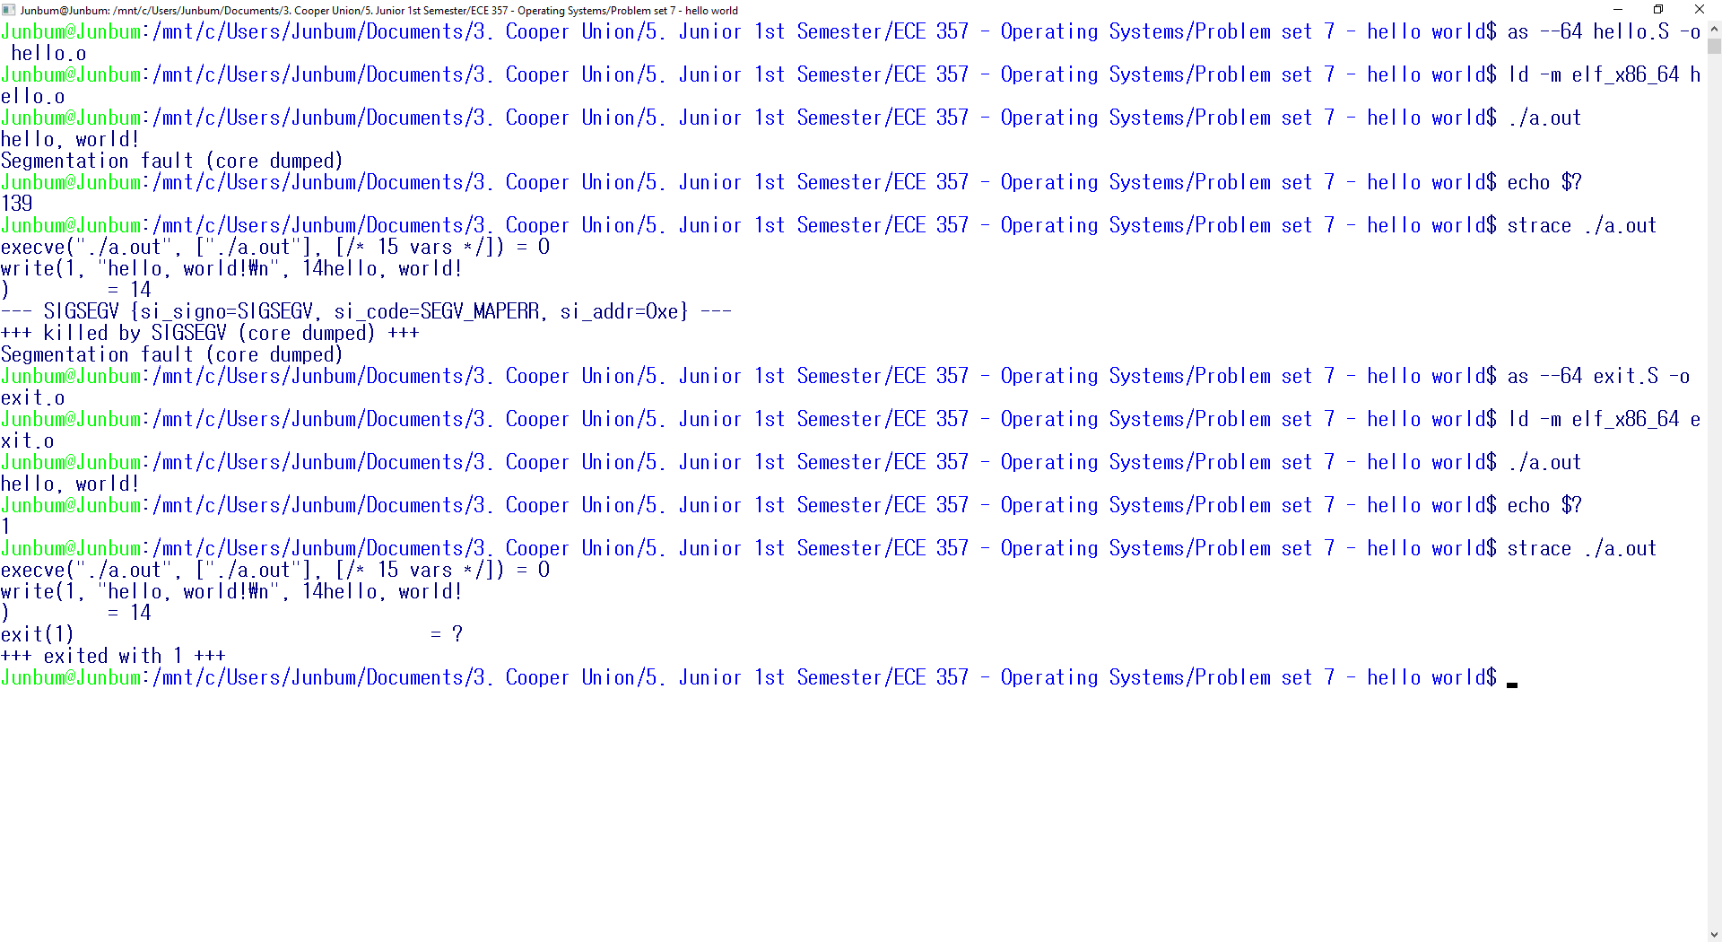

1. **Discussion**
   1. **Exit Code**

As indicated by strace and echo $?, the exit code for hello.S corresponds to a SIGSEGV. The value 139 from echo $? equals 128 + 11, which follows the UNIX convention errno 128 + signal number 11. This happens because rax is a volatile register. The rax register is not a valid address by the time the program terminates. This is corrected when we add exit syscall with value 1. This is verified by both echo $? and strace.

* 1. **System Call Validation**

1. Invalid Address for write string (rsi replaced with r10)

execve("./a.out", ["./a.out"], [/* 15 vars */]) = 0

write(0, NULL, 14) = -1 EFAULT (Bad address)

exit(1) = ?

+++ exited with 1 +++

1. Invalid System Call Number (syscall # $90)

execve("./a.out", ["./a.out"], [/* 15 vars */]) = 0

write(1, "hello, world!\n", 14hello, world!

) = 14

chmod(0x1, 030000356) = -1 EFAULT (Bad address)

exit(1) = ?

+++ exited with 1 +++

1. **Extra Credit**
   1. **Source Code – Syscalltime.c**

#include <stdio.h>

#include <unistd.h>

#include <sys/types.h>

#include <time.h>

#include <stdint.h>

void empty() {}

int main() {

struct timespec start, end;

clock_gettime(CLOCK_MONOTONIC, &start);

for(int i = 0;i < 1000000;i++)

empty();

//getuid();

//;

clock_gettime(CLOCK_MONOTONIC, &end);

unsigned long nanodiff = 100000000L *(end.tv_sec - start.tv_sec) + end.tv_nsec - start.tv_nsec;

printf("%lu nanoseconds elapsed.\n", nanodiff);

}

* 1. **Sample Run**

Junbum@Junbum:/mnt/c/Users/Junbum/Documents/3. Cooper Union/5. Junior 1st Semester/ECE 357 - Operating Systems/Problem set 7 - hello world$ gcc ec.c -O0 -o for

Junbum@Junbum:/mnt/c/Users/Junbum/Documents/3. Cooper Union/5. Junior 1st Semester/ECE 357 - Operating Systems/Problem set 7 - hello world$ gcc ec.c -O0 -o func

Junbum@Junbum:/mnt/c/Users/Junbum/Documents/3. Cooper Union/5. Junior 1st Semester/ECE 357 - Operating Systems/Problem set 7 - hello world$ gcc ec.c -O0 -o syscall

Junbum@Junbum:/mnt/c/Users/Junbum/Documents/3. Cooper Union/5. Junior 1st Semester/ECE 357 - Operating Systems/Problem set 7 - hello world$ ./for

**2001000 nanoseconds elapsed.**

**Empty for loop takes the least amount of time**

Junbum@Junbum:/mnt/c/Users/Junbum/Documents/3. Cooper Union/5. Junior 1st Semester/ECE 357 - Operating Systems/Problem set 7 - hello world$ ./func

**2845000 nanoseconds elapsed.**

**Empty function call takes a bit more time than the empty for loop**

Junbum@Junbum:/mnt/c/Users/Junbum/Documents/3. Cooper Union/5. Junior 1st Semester/ECE 357 - Operating Systems/Problem set 7 - hello world$ ./syscall

**290695000 nanoseconds elapsed.**

**Syscall takes about a hundred times longer than the other two operations.**

* 1. **Analysis**

The empty function call takes slightly longer than a pure for loop because it has to flag register and instruction pointer to the stack region every time a function call is made. This slows down the operation by a small margin. The cost of a syscall is much larger than an empty function call because in addition to establishing a stack pointer, it has to perform many more operations to get its job done. A lot of time is spent on entering kernel mode, returning back to user mode, and in pure kernel overhead, leading to a much more expense in CPU cost.